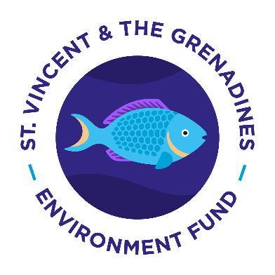
SVG Environment Fund
Ms. Louise Mitchell
Executive Director
louise@svgef.org
FOR IMMEDIATE RELEASE
May 4th, 2021

New Faces at St. Vincent and the Grenadines Environment Fund
The St. Vincent and the Grenadines Environment Fund is a non-profit company registered in St. Vincent and the Grenadines to support sustainable initiatives to promote the preservation of our beautiful environment and ecosystems as well as maintain the natural value of the islands. The SVGEF was formerly known as the Preservation Fund and has been supporting conservation projects in SVG since 2016.
The SVGEF wishes to announce two new members of our team. Our new chairman for the St. Vincent and the Grenadines Environment Fund is the Honourable Henry Channon. Mr. Channon’s family have been residing in St. Vincent and the Grenadines since 1975 and both his father and he have been the chairman of the Mustique Company and worked very closely with the Government of St. Vincent and the Grenadines. Mr. Channon and his wife Katie Channon share a deep connection and commitment to preserving and creating a sustainable environment for all our future generations. He is excited to be leading the Fund at this critical time in the history of St. Vincent and the Grenadines, as we grapple with the impact of the volcanic eruptions on our fragile ecosystems, forests and endemic species. Mr Channon takes over the chairmanship from SVGEF founder Bryan Adams.
The Fund is pleased to also announce its new Projects Officer/ Assistant to the Executive Director, Ms. Michele De Freitas. Ms. De Freitas is a Vincentian who completed her Bachelor of Science in Environmental Policy with Management at Everglades University, Florida. She has a great passion for the environment and in particular the topics of Climate Change and Ecosystem Preservation and Conservation.
By Louise Mitchell, Executive Director
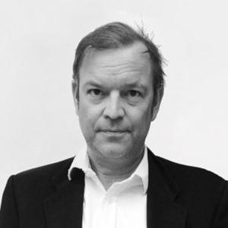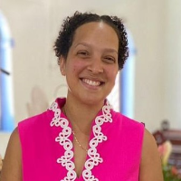
Hon. Henry Channon – Chairman Ms. Michele De Freitas – Projects Officer/ Assistant to Executive Director

-END-

